2021



**BEng (Hons) Electrical & Electronic Engineering**

**Final Year Project**

Smart Energy Meter

Student Name: W. R. B Weerasooriya

University Number: 179126073

Supervisor Name: Dr. Indrajanaka Mahakalanda

A FINAL YEAR PROJECT REPORT SUBMISSION IN PARTIAL FULFILMENT OF THE REGULATIONS FOR THE AWARD

OF BENG (HONS) IN ELECTRICAL & ELECTRONIC ENGINEERING AT THE UNIVERSITY OF SUNDERLAND 2017

**Acknowledgement**

**Table of Contents**

1.0 Chapter Introduction 6

1.1. Background 6

1.2. Rationale of the Topic 7

1.3. Problem Identification 7

1.4. Aim and Objectives 8

1.5. Scope 8

2.0 Chapter Literature Review 9

2.1.1. Genaral problems 9

2.1.2. Covid 19 problems 12

3.0 Chapter Methodology 14

3.1. Conceptual Design 01. Raspberry pi unit system 15

3.2. Conceptual Design 02 Arduino based system 15

3.3. Conceptual Design 03 Atmel microcontroller system 16

3.4. Selecting the Optimum Design and Justification 17

4.0 Chapter Chapter - Design and Implementation 18

4.1. Hardware Implementation 18

4.1.1. Microcontroller 18

4.1.2. GSM Module 19

4.1.3. Buck converter 20

4.1.4. Current sensor 22

4.1.5. PCB designing 23

4.1.6. Relay controller 24

4.1.7. Board diagram 25

4.1.8. PCB etching process 28

4.2. Software Implementation 31

4.2.2. Microcontroller programming 31

4.2.3. Basic setup. 31

4.2.4. Save data from power failure. 32

4.2.5. Current sensor programming 34

4.2.6. Web uploading 36

4.2.7. Web server 37

4.2.8. Connect .php 38

4.2.9. Read php 38

4.2.10. Write php 39

4.2.11. Index php 39

5.0 Chapter Testing and Analyzing 41

5.1.1. Gsm test part 41

5.1.2. Web server test part 42

5.1.3. Finale test 43

6.0 Chapter Conclusion and Further Development 45

References 46

**Gantt Chart** 47

**Table of Figure**

Figure 1.1 No.of consumer account by tarrif 6

Figure 1.2 News- Meter reader attracted by house owner. 7

Figure 2.1 NEWS: meter reader attacked by home owne (liveat8, n.d.) 9

Figure 2.2 News Minister talk about palmadulla incident 10

Figure 2.3 NEWS : reader attacked by dog 10

Figure 2.4 NEWS gossiplanka 11

Figure 2.5 NEWS electricity bill problems 12

Figure 3.1 raspberry pi unit 15

Figure 3.2Arduino board 16

Figure 3.3 atmel atmega microcontroller 16

Figure 11 atmega 328 18

Figure 12 speed grade chart from datasheet 19

Figure 13 sim800L 19

Figure 14 sample AT command from datacheet 20

Figure 15 lm2596 circuit 21

Figure 16 LM2596 buck converter 21

Figure 17 current sensor 22

Figure 18 hall effect of current sensor 22

Figure 19 calibration and equation generate 23

Figure 20Eagle cad interface 23

Figure 21 schematic diagram 24

Figure 22 Relay controller part 24

Figure 23 board diagram 25

Figure 24 complete board 26

Figure 25 Eagle Cad layer selection 26

Figure 26 finale Board layer 27

Figure 27 JLC PCB web preview 27

Figure 28 the printed photo paper 28

Figure 29 Remove unwanted copper using feric chloride 28

Figure 30 PCB agter etching 29

Figure 31 pcb making process 29

Figure 32Finale PCB 30

Figure 33 After soldered 30

Figure 34 microcntroller basic setup 31

Figure 35main function init 32

Figure 36 input voltage reading path 33

Figure 37 power fail identify 33

Figure 38current sensor output 34

Figure 39 microcontroller input 34

Figure 40array maximum value find logic 35

Figure 41 web uploading part coding 36

Figure 42 database 37

Figure 43 web file manager 37

Figure 44 connect web page 38

Figure 45 read web page 38

Figure 46 write php file 39

Figure 47 home page 40

Figure 48 index php sample code 40

Figure 49 GSM test unit 41

Figure 50postmen web app 42

Figure 51 web page after post request 42

Figure 52 60w filament bulb 43

Figure 53 the circuit before test 43

Figure 54 while testing 44

Figure 55 the web page after test 44

# Introduction

## Background

In Sri lanka electricity consumption grown by daily. It means more connections are created daily and need more labors to maintain this. Manpower need to read the bill and sometimes manpower need to cutoff the connections and restore these connections. In Colombo city there are 623,694 connections in 2016. Number of domestic connection is 5,243,433 and Religious is 36,382. The grows of connections in 2017 is 7.0%. So we need some smart method to maintains this. (board, 2017)

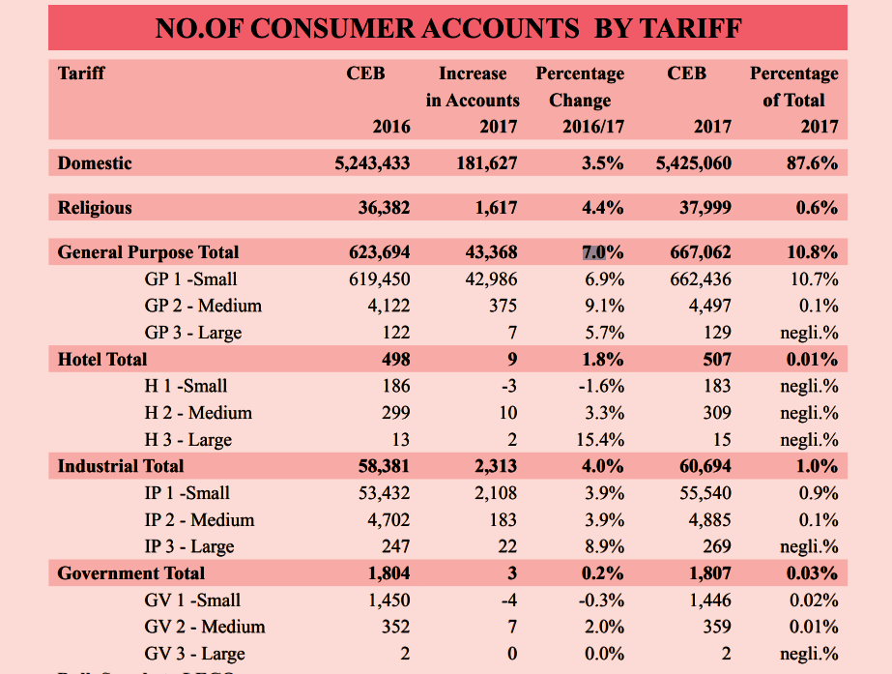

Figure 1.1 No.of consumer account by tarrif

The covid 19 situation reminded need of smart energy meter system. Covid 19 made the barrier between customer and meter reader. It made many problems in sri lanka.So I though we need smart electricity meter system with some web and database features. I think the customer has to ability to view his energy consumption and electricity board able to maintain connection through online and view all customers meter reading separately.

## Rationale of the Topic

The number of electricity connection rapidly increased in sri lanka.the smart meter system give ability to electricity board to control it through online. And calculate the bill online. This system replace meter reader and connection maintains labour. With this system customer can view his energy and power consumption through online.

## Problem Identification

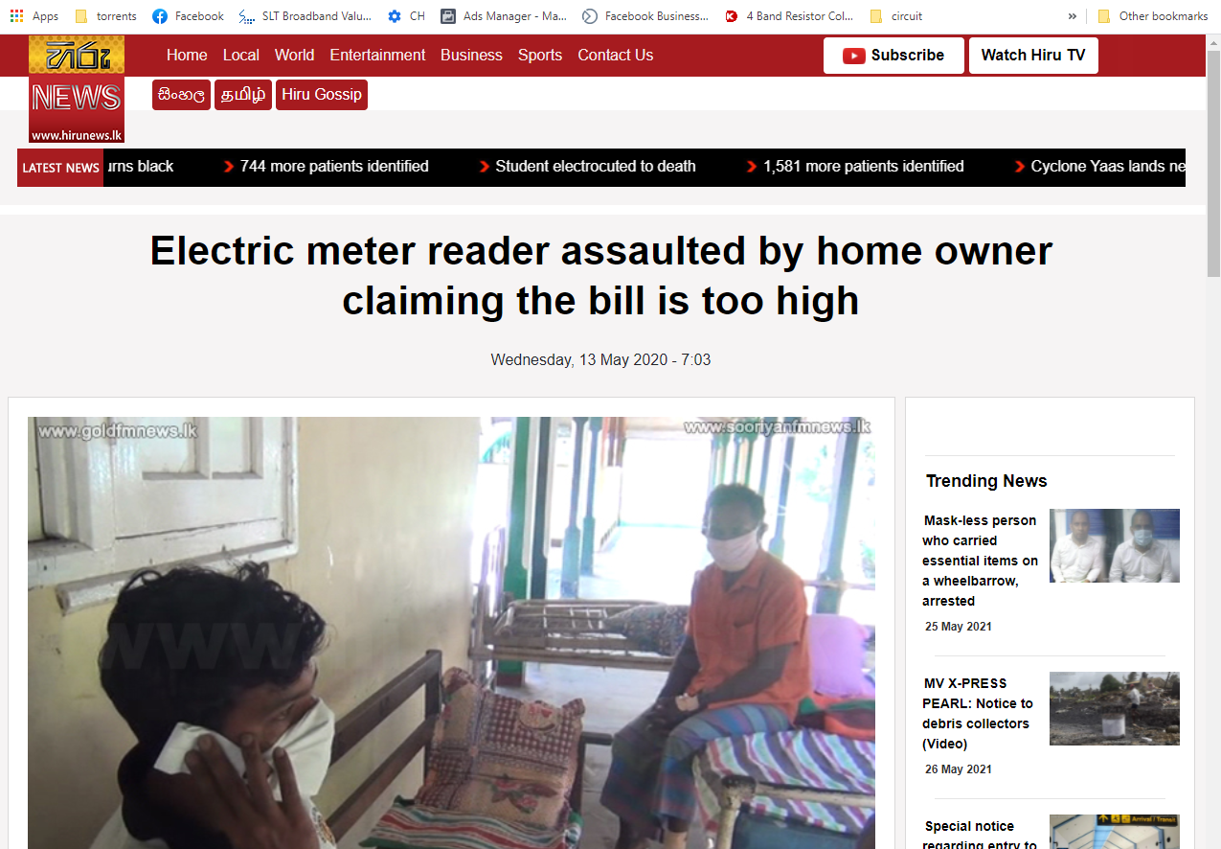

Figure 1.2 News- Meter reader attracted by house owner.

Meter reader is a field job.so meter reader has to face many. Problems in sri lanka. sometimes there are weather problems. sometime social problems. In sri lanka many people live with different problems.so they got angry easily and they try to argue with people. Sometimes the meter reader attracted by dogs.

In this covid 19 situation meter reader cannot visit houses. So the bill was predicted and it has many errors

Sometimes customer does not pay their bill. So electricity board cut off their supply.it need more manpower and customer needs to pay settle charges.

There are no way to customer see their power and energy consumption through online.

## Aim and Objectives

* The product will calculate energy same as normal energy meter
* The product will calculate real-time power
* The meter reading and power values will save in a database through internet
* Electricity board can see meter reading andcontrol power connection online

## Scope

* The current sensor read the current supply and generate small voltage based on current amount
* The generated voltage is red by atmega 328 microcontroller and send it to website using sim800l gsm module
* The website saves the retrieve value in database and show values in homepage
* Every time when upload data to.web, gsm module read website feedback and control the output relay.

# Literature Review

Meter reader is a field job. So reader has to face many type of problems.

### Genaral problems

Most of srilankans had to suffer in different ways . so the get angry easily.so they always try to argue with people. Follow incident is a proof for this.



Figure 2.1 NEWS: meter reader attacked by home owne (liveat8, n.d.)

The news about above figure is the meter reader attracted by home owner because of the billed amount is very high. After both persons were admitted to palmadulla general hospital

After that incident it is not the end of story. The problems grew and the minister had to control it. Minister of Power and Energy Mahinda Amaraweera has requested the acting inspector General of police Chandana Wickramaratne to conduct a stringent investigation pertaining to the assault incident of an electricity meter reader in pelmadulla.

Minister Amaraweera Instructed the Secretary to the Ministry of Power and Energy, Wasantha Perera to direct a letter to the Acting IGP and request stern legal action to be taken against the suspect involved in the incident. Minister Amaraweera noted assaulting a state official while on official duty sets a wrong example and stressed it is the government’s responsibility to ensure the safety of state officials within the sector. (Radio, n.d.)

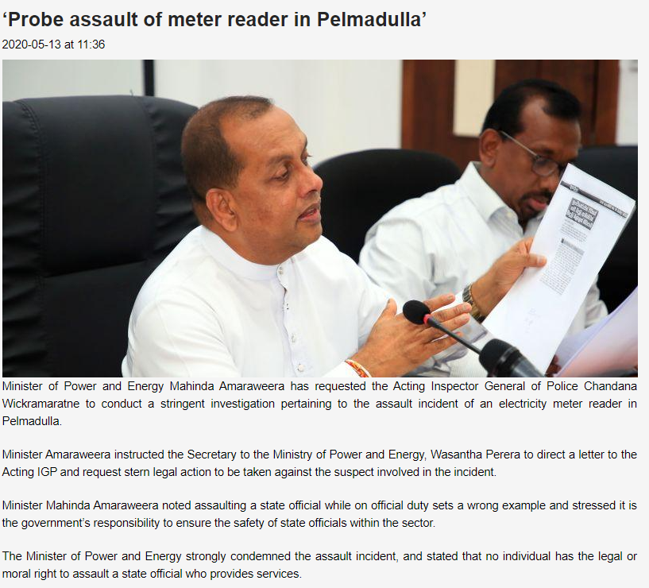

Figure 2.2 News Minister talk about palmadulla incident

Below incident is also like about above one.the reader attacted by dog

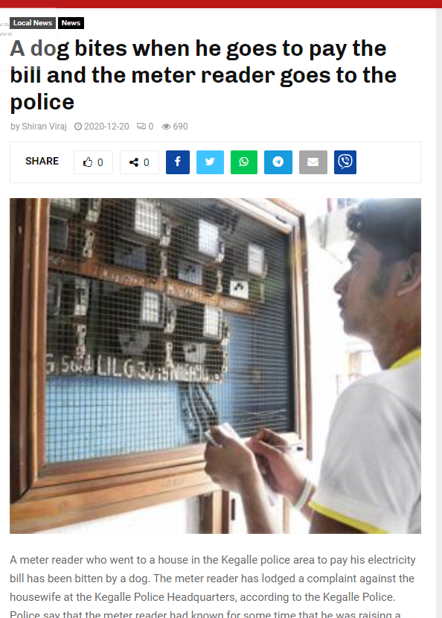

Figure 2.3 NEWS : reader attacked by dog

From the news site

“A meter reader who went to pay the electricity bill of a house in the Kegalle police area has been bitten by a dog. The meter reader has lodged a complaint against the housewife at the Kegalle Police Headquarters, according to the Kegalle Police. Police say that the meter reader had known for some time that he was raising a large dog that had bitten him in the house.

Police investigations have revealed that the meter reader had paid electricity bills to the houses in the village and then talked to Thea before going to the house where the big dog is kept and then a young woman who was in the house had come to the yard of the house to see who was talking.

According to the police, the meter reader had told the girl who was in the yard from a distance to tie the dog or not. The girl has stated that the dog is tied inside the house. The meter reader had come to the house and looked at the electricity meter while recording the electricity bills. The girl was not able to catch the dog and with the help of the meter reader, the girl had tamed the dog and had taken the dog home and locked it in a room, police said. An officer of the Kegalle Police Headquarters has visited the house where the incident took place recently and carried out a preliminary investigation. Both parties are due to be summoned to the Kegalle Police Headquarters at a future date, police said.” (mediahumanright, n.d.)

Below news is also about this type.

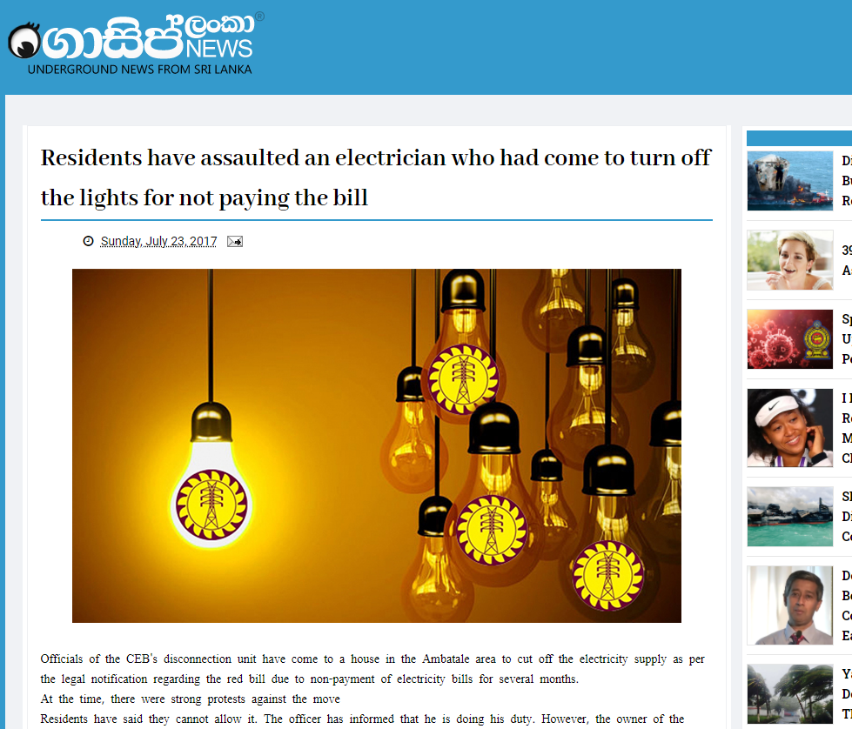

Figure 2.4 NEWS gossiplanka

This news says, the CEB disconnecting unit have come to a house in the Ambatale area to cut off electricity supply as per the legal notification regarding the red bill due to non payement of electricity bills for several months. At the time there were strong protests against the move. Residents have said they cannot allow it. The officer has informed that he is doing his duty. However the owner of the house hadgot into an argument saying that he would have to fight if the electricity was cut off.

Owner despite their their duty to the officer acted in the same time the house had weapons and bars would come into the home owner has taken to attack after attack on the officer. (Anon., n.d.)

These are the common general problems when meter reading is done by manually.This is not end of this after the covid 19 pandemic season the more problems are created about this section

### Covid 19 problems

In this covid 19 situation the main problem is meter reader cannot take meter reader values. In this problem government gave different solutions. The government approved solution was predict the meter reader values using compare with old bills. But it created different problems.

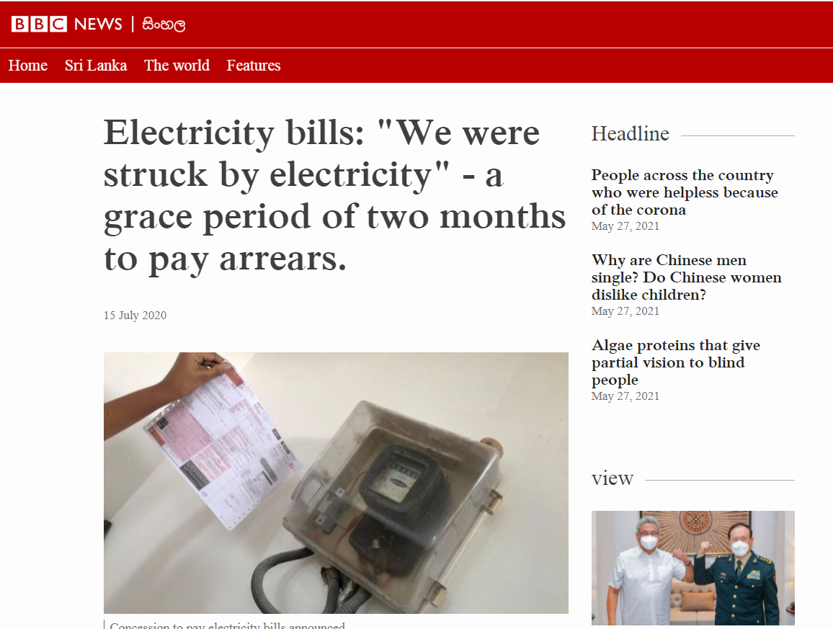

Figure 2.5 NEWS electricity bill problems

Above incident was happen in 2021. People said it is hard to pay all bills at same time.

After government has decided to allow the public to pay their electricity bills for March, April and May according to the February bill or the minimum bill received thereafter.

# Methodology

]In this design we have to read the current sensor data and send it to the microcontroller. The important part is accuracy . because if the accuracy got decrease project will fail. So we need suitable method to calibrate the sensor

After calibrating the sensor microcontroller need to read sensor output after reading the output microcontroller has to upload data to web server so it need the module has to ability to web site.

Web site does not mean just one web site. It need several page to maintain all web functions. There are two main web page not connect with users. First web page is read web page . the read web page job is retrieve the value from database and create variables for send. The other web page is write web page. The write web page job is take the retrieved value from gsm module and write it to database.

The main web page is home (index) page . the home web page make interface to user. It get value from read web page and show to customer, the second job of home page is send the button state to the write page.

When microcontroller runs these all functions it need some battery backup option and power cut identify method to save data to rom when power outages

Web page

Database

Smart meter

## Conceptual Design 01. Raspberry pi unit system

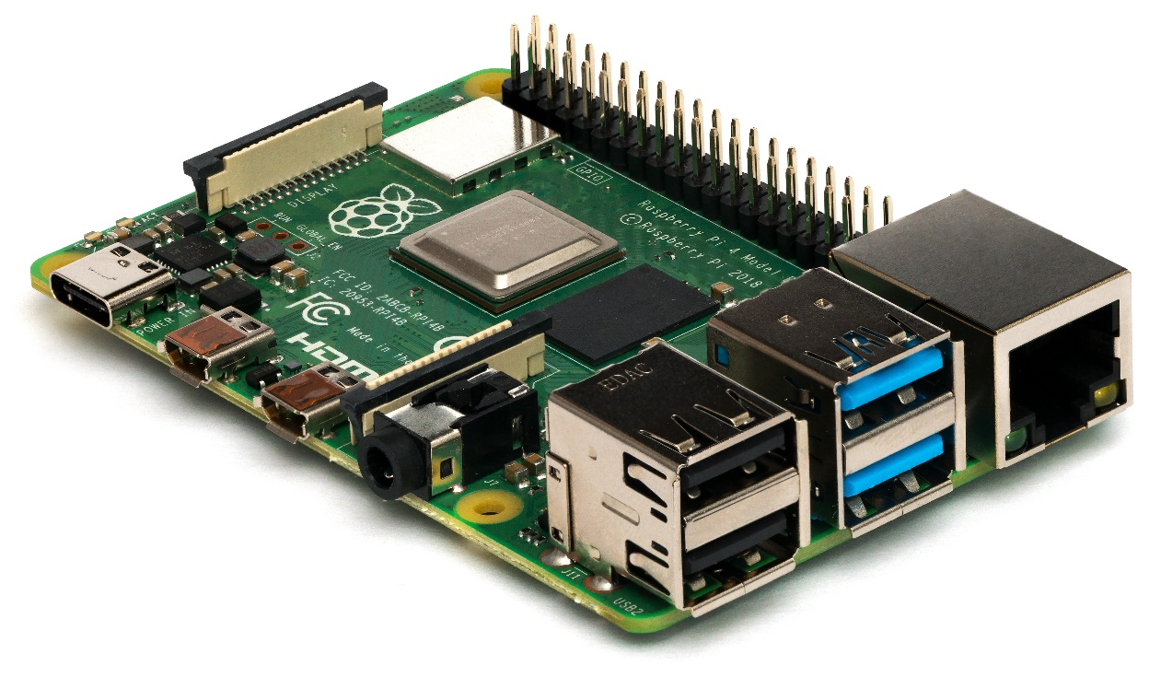

Figure 3.1 raspberry pi unit

Raspberry oi is a small single board computer . we can use keyboard, mouse with this such as computer it is popular device in IOT based application and robotics. So in this project we can use this more easily . it is very easy handle multitasking project like our smart energy meter. It has more IO pin to use with sensor and communication devices.

In this project we have to work with web server and other gsm functions. So it is very easy if we use raspberry pi unit. After using that it is very easy to upgrade another platform with this.

Using raspberry pi we have more option to connect internet like wifi, Ethernet cable. And this is so fast with calculating functions and we can update web server very fast.

## Conceptual Design 02 Arduino based system

Arduino is open source platform. so any one has permission to develop it so it getting very popular day by day. Using Arduino we can make prototype device easily and it is very low cost. So we can use most of sensors and modules easily with them.

Considering this project Arduino is also very suitable. We have different type of gsm modules to connect with it. And most of them are not very expensive. Another advantage is using Arduino is there are thousand examples on internet. So we can easily try different examples with them

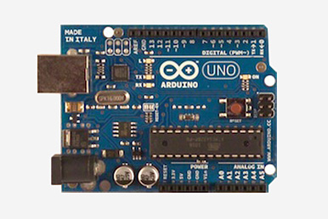

Figure 3.2Arduino board

## Conceptual Design 03 Atmel microcontroller system

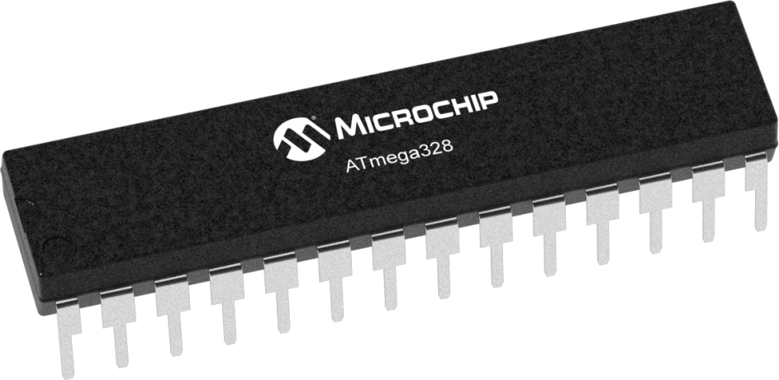

Figure 3.3 atmel atmega microcontroller

Atmel AVR is a family of microcontrollers developed since 1996 by Atmel, acquired by Microchip Technology in 2016. These are modified Harvard architecture 8-bit RISC single-chip microcontrollers. AVR was one of the first microcontroller families to use on-chip flash memory for program storage, as opposed to one-time programmable ROM, EPROM, or EEPROM used by other microcontrollers at the time. (Anon., n.d.)

So it is designed for industrial use. Atmel has large family series so we can easily choose microcontroller from them

Atmel microcontroller has more interrupt than other microcontrollers. It is very valuable when we do project like smart energy meter. Because the sensor like current sensor need realtome calculating.

## Selecting the Optimum Design and Justification

After Considered following points I chose atmel microcontroller for this project

* Size

In this case we need consider about size. Because when size became very large the circuit is also very large. Sometimes it give installation problem.After considered about size of the microcontroller , the atmel chip is the smallest one.

1. Durability.

When we selling a product , we have to give a warranty time.so durability is very important matter. In this case raspberry pi and atmel microntroller are ok. But Arduino is a development board . when we connected module and sensors to Arduino with jumper wires. After long time the it gave connection problems so Arduino is not suitable for this design.

So next work is choose one from atmel and raspberry pi. . raspberry pi is also have good durability. But in this case , the power supply of our device is normal electricity distribution in sri lanka. In srilanka some area has many power outages. But raspberry is not suitable for use in that areas. So in this case I choose atmel microcontroller.

# Chapter - Design and Implementation

In this project there are two main implementation. There are hardware implementation and software implementation.

## Hardware Implementation

Before this part , first lets get to know about components.

### Microcontroller

This is the main device of this project . because this part take control all sensors and modules. In this project I chose atmega 328 as controller.

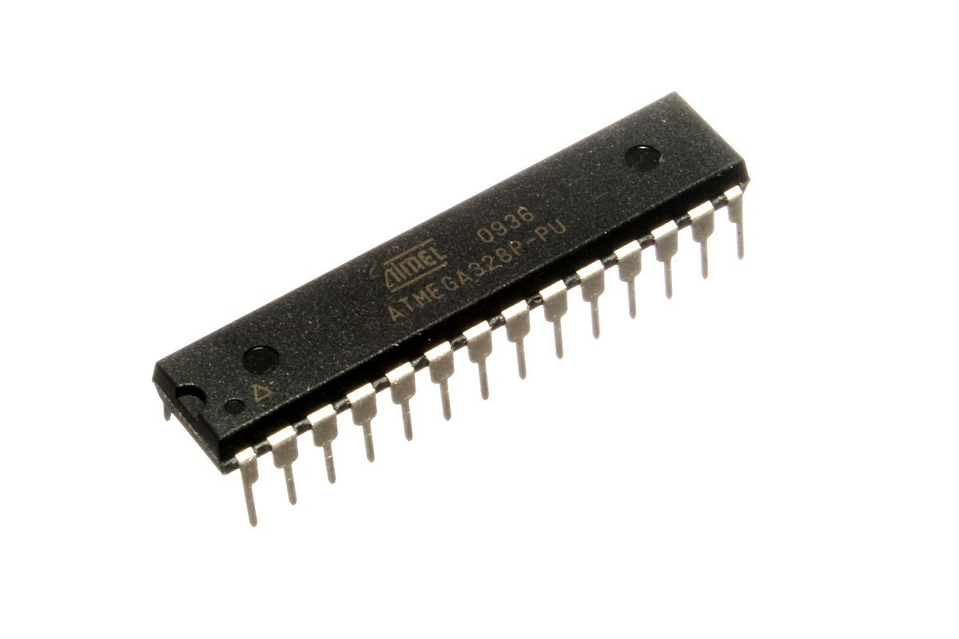

Figure 11 atmega 328

There are few reasons to chose atmega 328 as main controller

* Atmega 328 is atmel;s mid range microcontroller, it has 32kb flash memory for flash and 2kb ram memory for calculation. Other important is it has 1kb eeprom memory. So we can use eeprom to save kwh unit value while power cut.
* It has one USART commnucation port. So we can use this port to commnucate with GSM module.
* Price and availability – atmega 328 is very popular microcontroller in sri lanka. So it is easy to find out in most electrical shop and its price around 500 lkr
* Logic level change ability- using different clock frequencies it can operate with different voltage levels. It very helpful when using 3.3v logic level devices like gsm modules

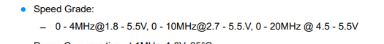

Figure 12 speed grade chart from datasheet

* Interrupt functions- using ADC functions we can calculate energy simultaneously with the help of registry functions.

### GSM Module

We need gsm module to upload and retrieve data to web server. So this function I chose sim800l module . in market there are different type of gsm modules. But sim800l is very small and low cost module.

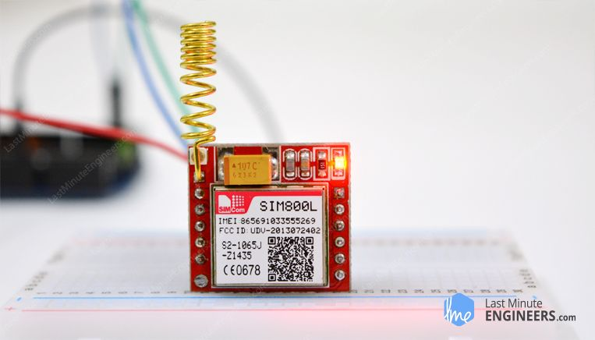

Figure 13 sim800L

Using “AT” command we can communicate with GSM module

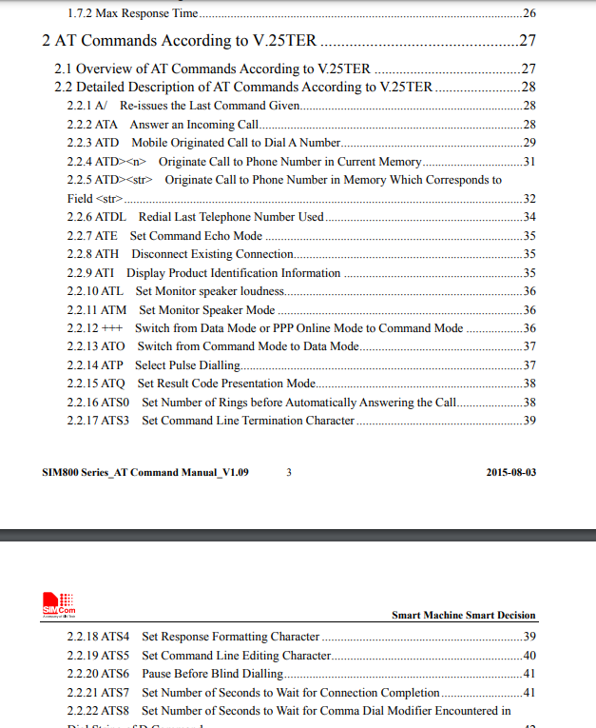

Figure 14 sample AT command from datacheet

### Buck converter

Buck converter purpose is regulate the input voltage to selected voltage. In this circuit the logic voltage is 3.3v , but we had to use 3.3v regulator as buck converter. But sim 800l need high amount of current for connect to the network. But regulator cannot give that high current.

Buck converter has feedback system for current balancing. The coil in the buck converter store the electrical energy as magnetic energy.

When high current need, the coil convert magnetic energy to electric energy.

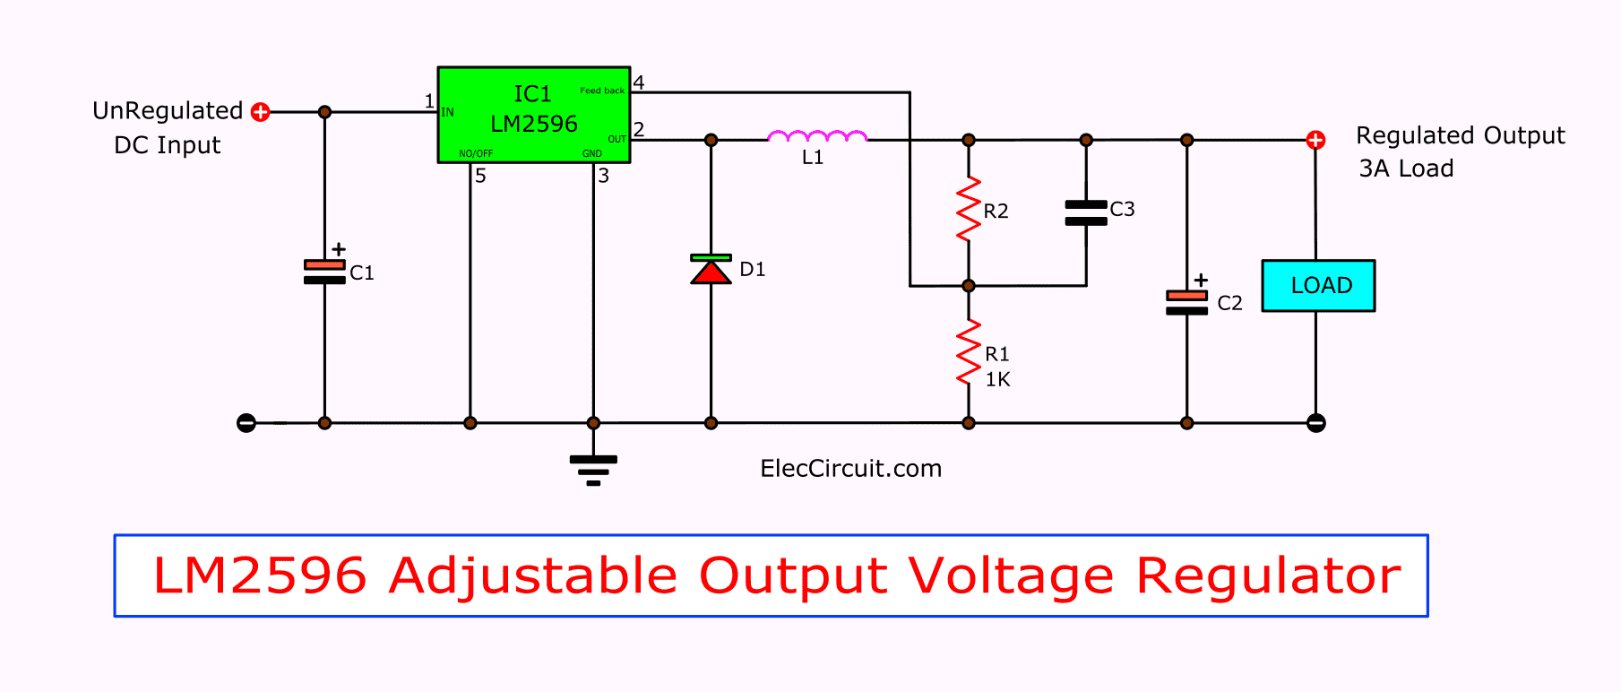

Figure 15 lm2596 circuit

The R1 and R2 resistor give different voltage to lm2596 buck converter . using this signal level buck converter control the output.

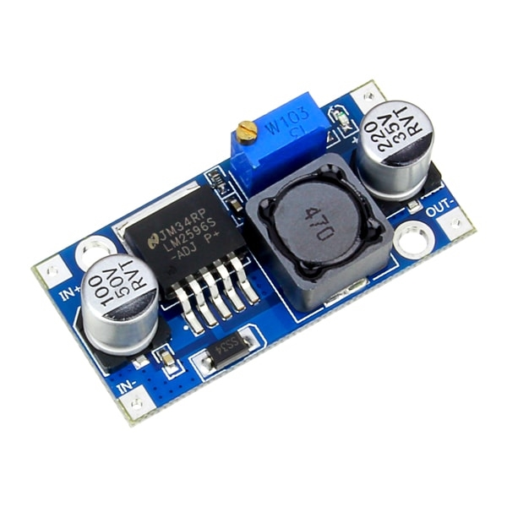

Figure 16 LM2596 buck converter

### Current sensor

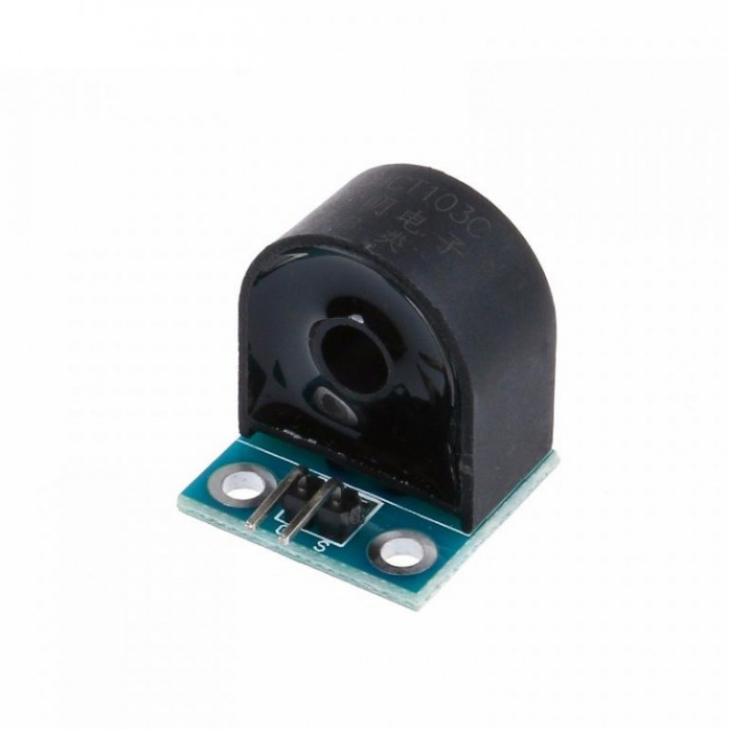

Figure 17 current sensor

Projects needs a current sensor to calculate the home use amphire.. so I chose 5A current sensor to calculate this. When wire goes in the hole of the current sensor, the current line start flowing.we call it hall effect

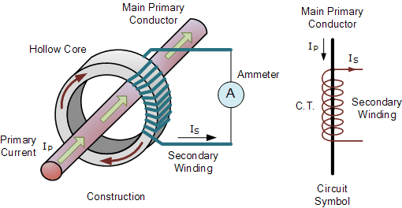

Figure 18 hall effect of current sensor

Before use this sensor we need to calibrate the sensor by adding different watt size bulb and after check generated voltage.

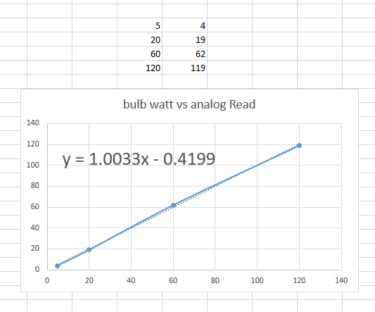

Figure 19 calibration and equation generate

### PCB designing

For a PCB design I chose Eagle cad software . Eagle is paid softwere. But they give free edition to education purpose. It has two different layers. Main one is schematic side. The circit path drawn in schematic side and the board path will generate in board side

Eagle cad has thousand of library for thousand components. It it is easy do a new design with.Eagle cad.

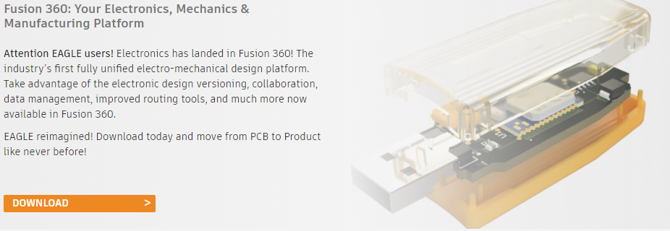

Figure 20Eagle cad interface

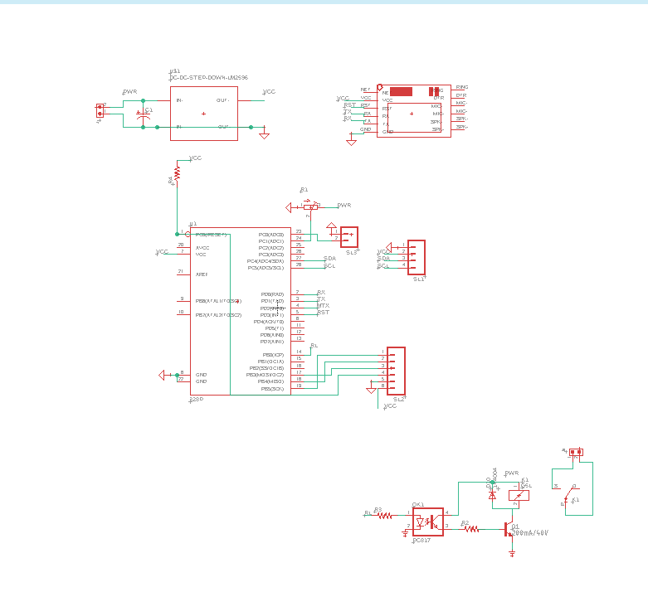

Figure 21 schematic diagram

### Relay controller

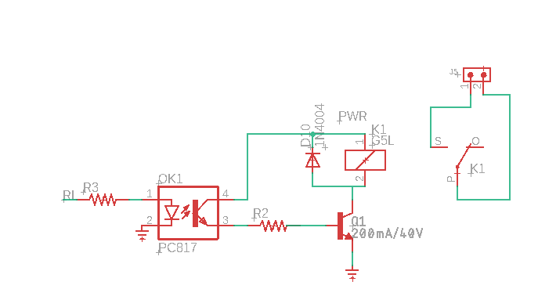

Figure 22 Relay controller part

Above schematic part is relay controller part. The bc547 transistor switch the relay coil. The diode with relay coil known as flyback diode. The purpose of flyback diode is filter the backEMF.

But sometimes flyback diode cannot filter all Back EMF. May be it will be harmful to microcontroller side. So PC817 octacoupler purpose is isolate the microcontroller side from relay side.

After completing schematic diagram the board side shown as this.

### Board diagram

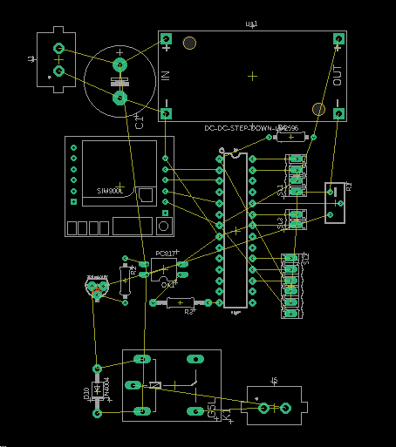

Figure 23 board diagram

After this we have to complete the path using router tool.

Eagle cad softwere allow different size of pcb paths. In this project I chose 70 mil as pcb path thickness.

Eagle cad has autorouter option. But I think autorouter does not give perfect output. So I done with it manual routing.

After Manual routing pcb board shown as below figure.

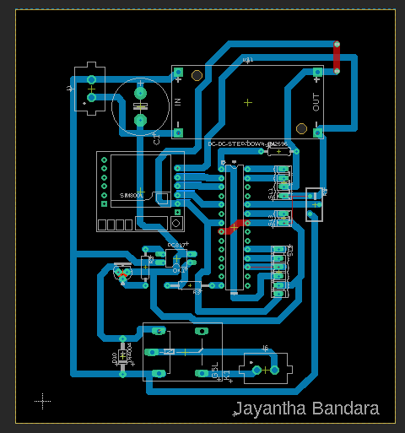

Figure 24 complete board

Eagle have layer select options. In this option we can select layers what we want.

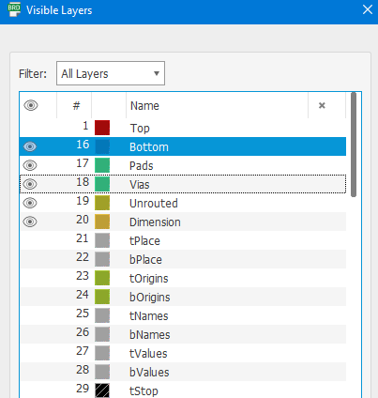

Figure 25 Eagle Cad layer selection

After selected suitable layers. The board path look like this.

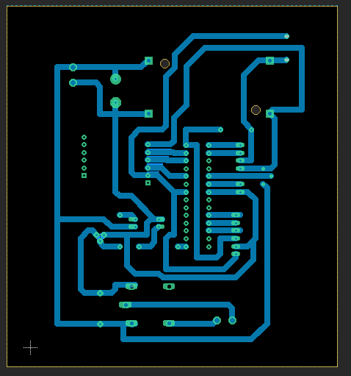

Figure 26 finale Board layer

The next part is print the board. Firstly I tried import pcb from china by sending my design.

But there are time problem and covid 19 problem made high shipping cost.

Below design is web preview from china JLC PCB company.

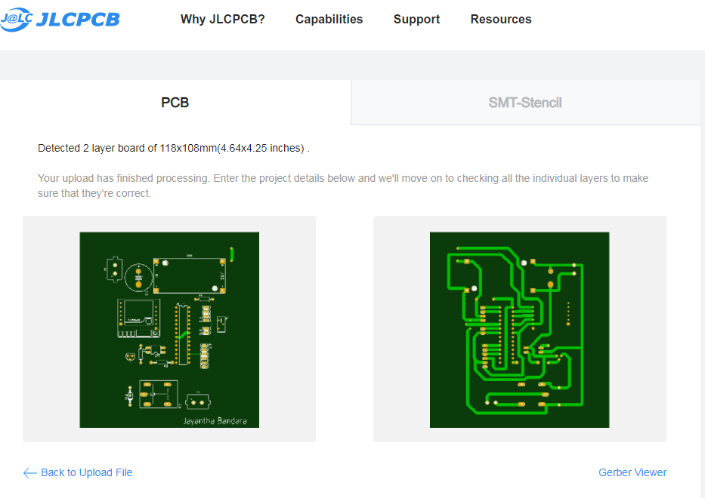

Figure 27 JLC PCB web preview

### PCB etching process

The first step is PCB etching is Print the pcb

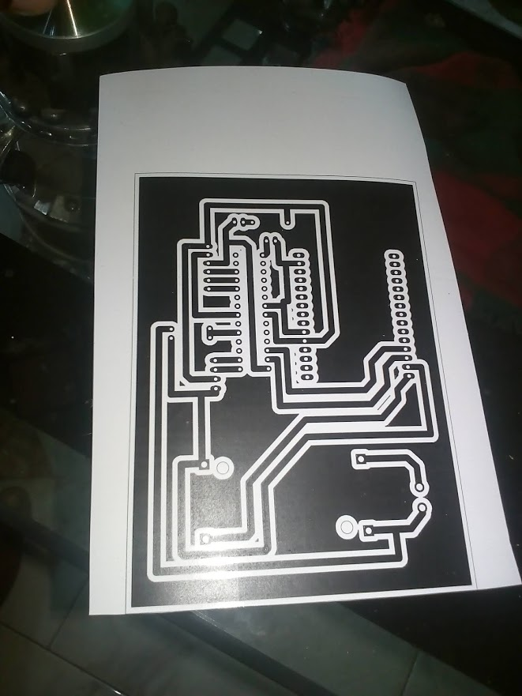

Figure 28 the printed photo paper

After printing the paper, the photo paper was aligned and paste to copper board using heat transfer method..

The next step is remove unwanted copper using ferric chloride.

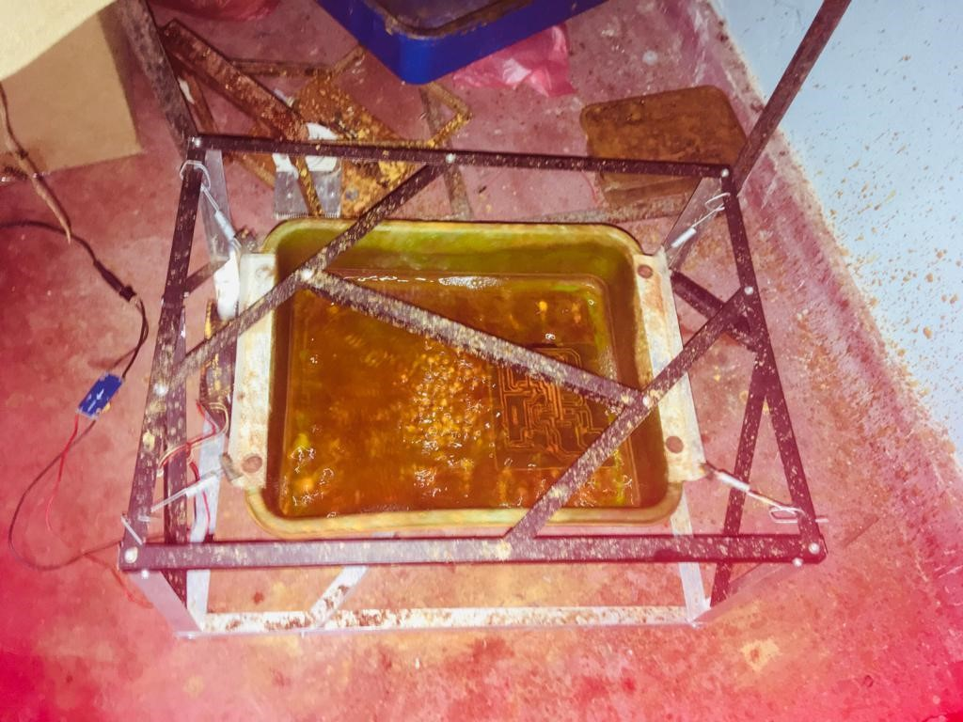

Figure 29 Remove unwanted copper using feric chloride

After while the PCB shown below

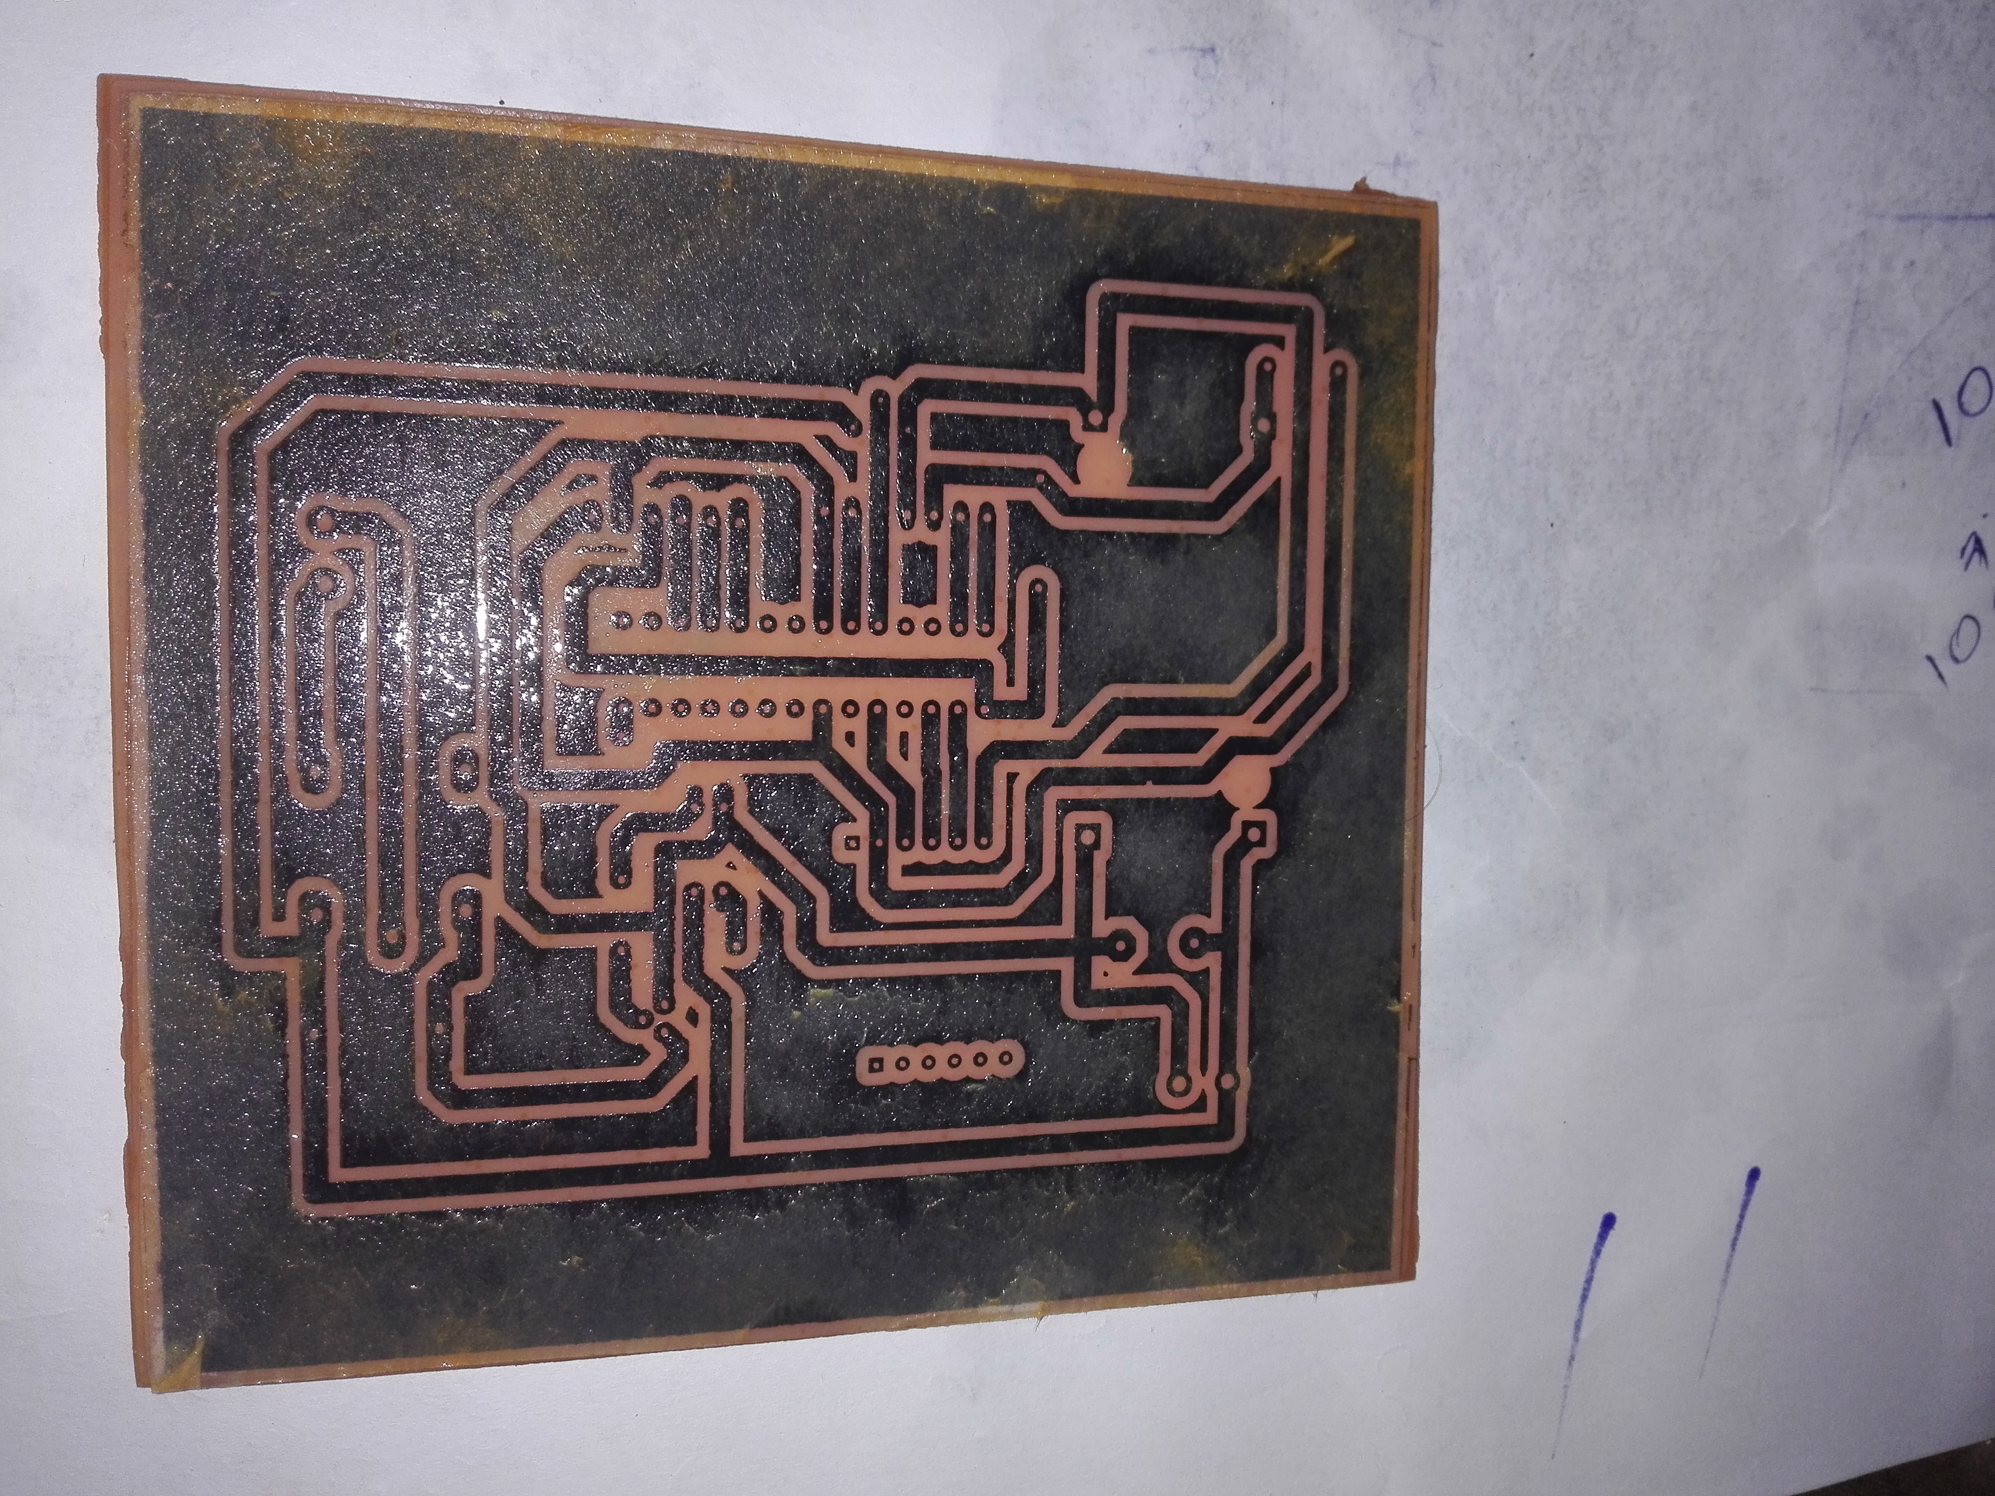

Figure 30 PCB agter etching

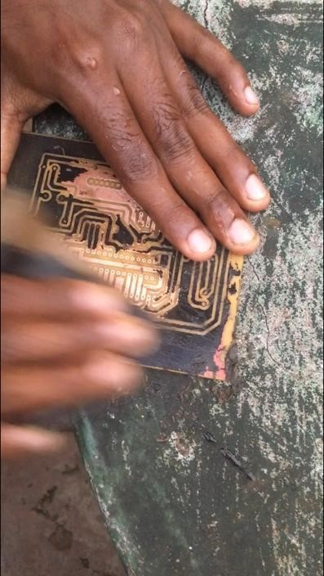

Figure 31 pcb making process

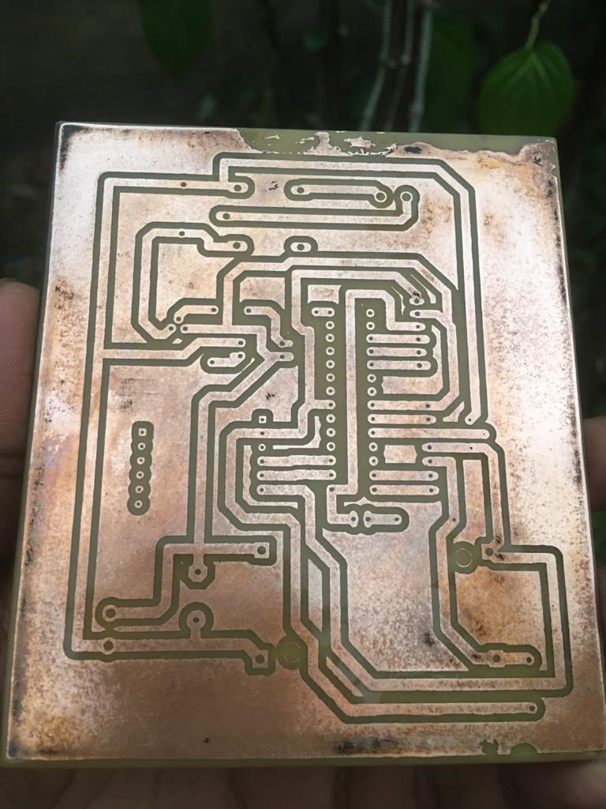

Figure 32Finale PCB

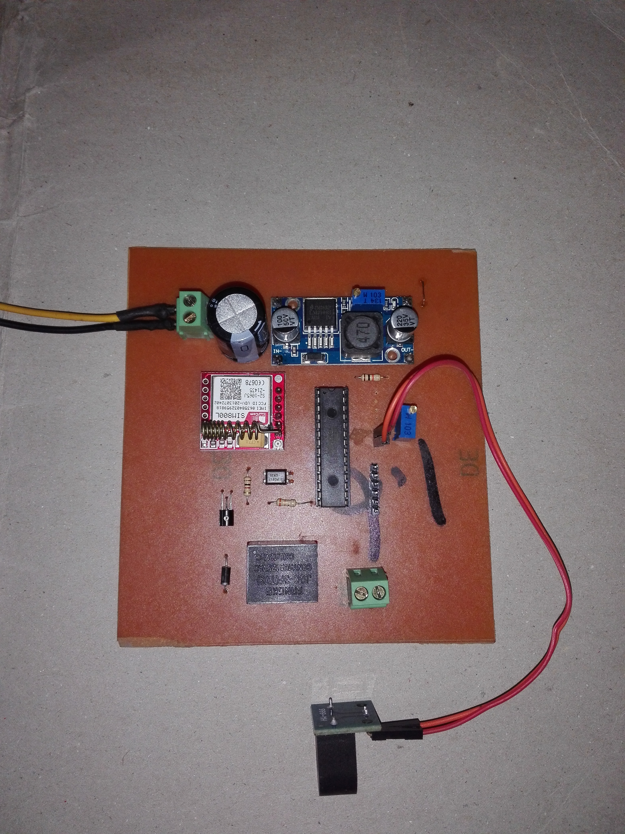

Figure 33 After soldered

## Software Implementation

In this project there are two type of software Implementation

* + - * 1. Microcontroller programming
        2. Web programming

### Microcontroller programming

In microcontroller the programming ide is atmel studio software and programmer is atmel ice device. Atmel ice has debug feature. It is very helpful while programming.

### Basic setup.

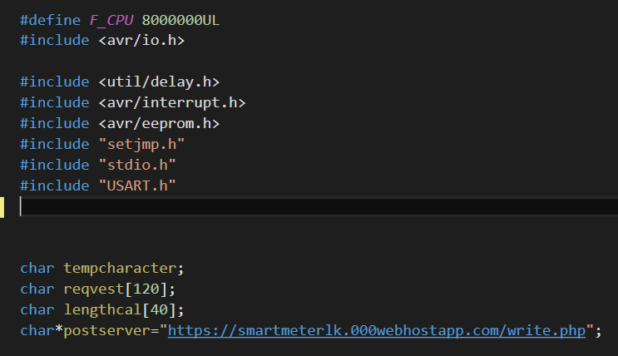

Figure 34 microcntroller basic setup

. F_CPU value is microntroller oscillating speed. It is need for real time timer calculation.

Delay.h library help to add delay to programme. Interrupt.h library needs for add interrupt function like current senser reading. Eeprom,h library helps to save last unit reading when power cut.

Setjump.h is not essential function. But it helps for manage programme struck problems. stdio.h is standert c++ library. It uses for string functions. USART.h uses for serial communication with sim800l module.

“<https://smartmeterlk.000webhostapp.com/write.php>” is web site that collect data from gsm module.

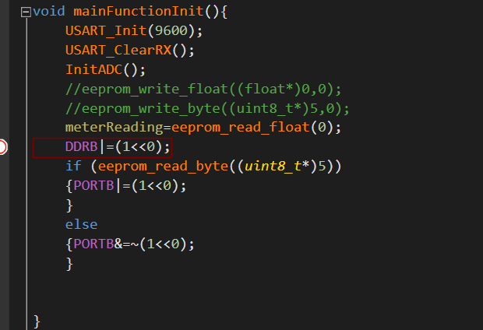

Figure 35main function init

This part initialize the main function of programme. USART_Init(9600) main initialize serial communication with 9600 baud rate. USART_ClearRX(); means clear serial communications memory.

After basic functions programme reads unit valuve from EEPROM address 0.

“(eeprom_read_byte((uint8_t*)5)” gives last meter relay state.

### Save data from power failure.

This is very important function circuit . it is save data from power failure. So I added some method to identify power failure. I added 1000uf capacitor before buck converter. When power fail the circuit run few millisecond using capacitor power . this circuit design for run buy 12V. after power fail the input voltage decrease slowly. When input voltage is small than 10V, the programme writes last unit count to eeprom.

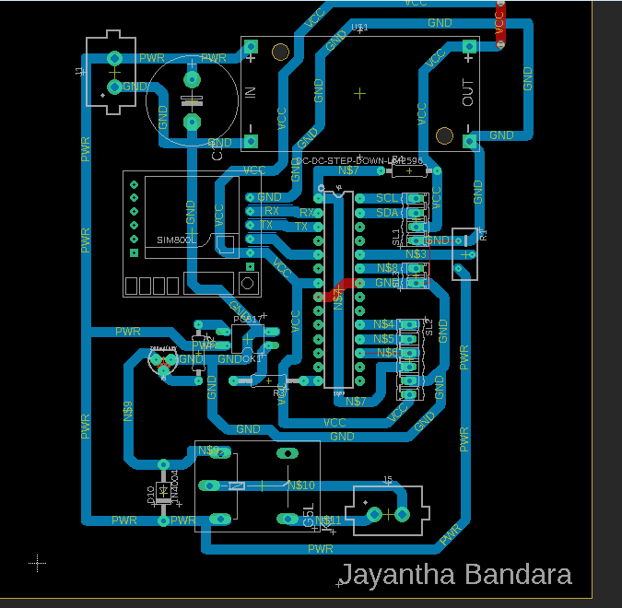

Figure 36 input voltage reading path

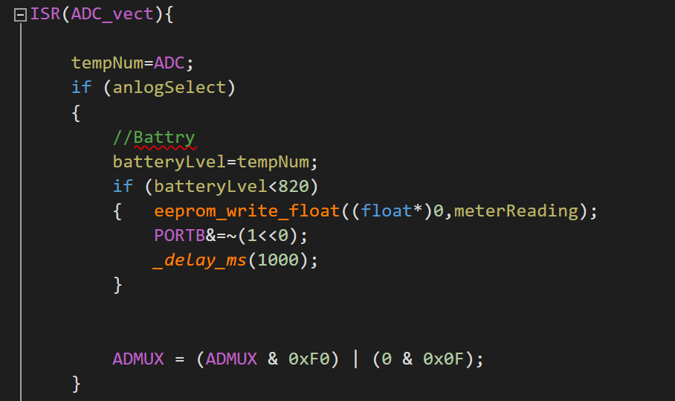

Figure 37 power fail identify

When input voltage lower than 12V the unit value writes to eeprom.

### Current sensor programming

When current flows through current sensor. It gives output like below.

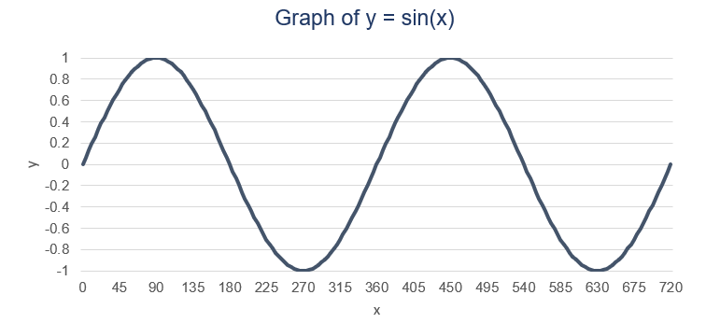

Figure 38current sensor output

But microcontroller does not like this. Because microcontroller does not suppor minus output.

So microcontroller input like below figure.

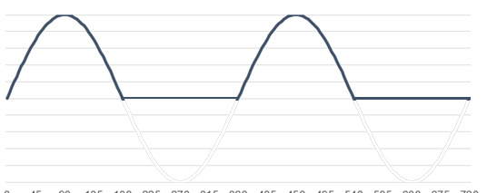

Figure 39 microcontroller input

When after checked the microntroller input value like this.

0,22,45,55,45,22,0,0,0,0,0,0,0,0, 0,22,45,55,45,22,0,0,0,0,0,0,0,0

So I had to write a programme find maximum value from this number arrey.

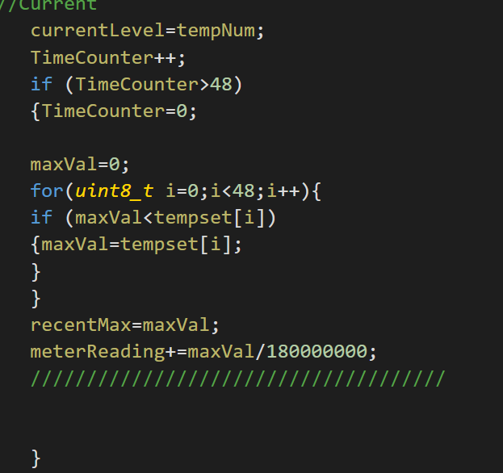

Figure 40array maximum value find logic

### Web uploading

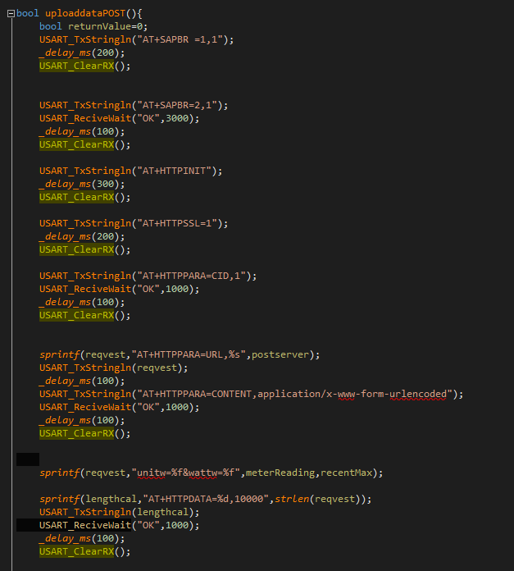

Figure 41 web uploading part coding

Above picture shows the command use in data uploading.

“AT+SAPBR” functions use for initialize data connection. “AT+HTTPINT” command start data connection. “AT+HTPSSL=1” command ready gsm module for ssl encryption. This ssl encryption need for secure data transmission.

“AT+HTTPPARA” command uses for give parameters to .gsm module. .

“AT+HTTPDATA” command retrieves data from web server this data includes relay control parameter.

### Web server

I chose 000webhost service my web site. 000webhost powered by hostinger.

First I created database for store unit and power data.

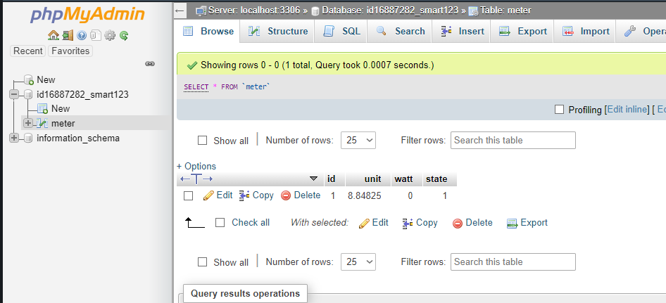

Figure 42 database

PHP my admin is data base control system. This data saved at meter table from id16887282_smart123 database. The id column means data id. The unit column save the unit value and the watt column save power. The state means relay state.

**Web page folder**

**000webhosting offers file manager service to save web pages.**

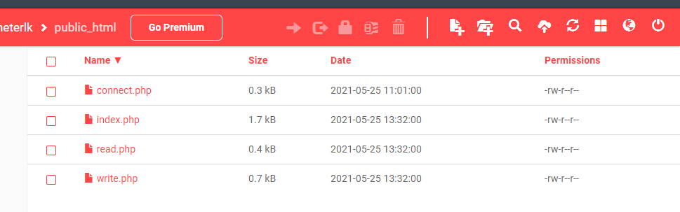

Figure 43 web file manager

### Connect .php

Connect.php is most important web page in this site. The duty of the connect web page is. Connect data base to web pages.

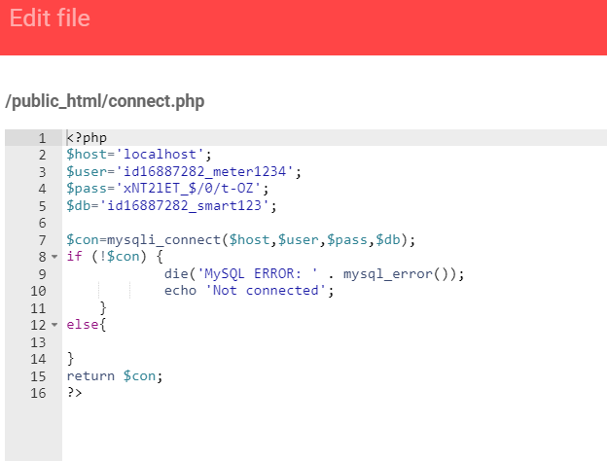

Figure 44 connect web page

The written language is php. First line is database main parameter define lines.

### Read php

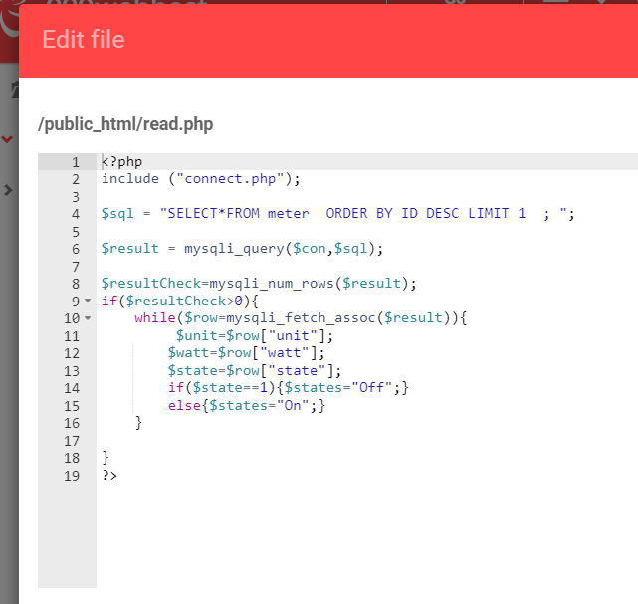

Figure 45 read web page

Read php file retrieve data from data base table and creat variable s. this variables send to home page.

### Write php

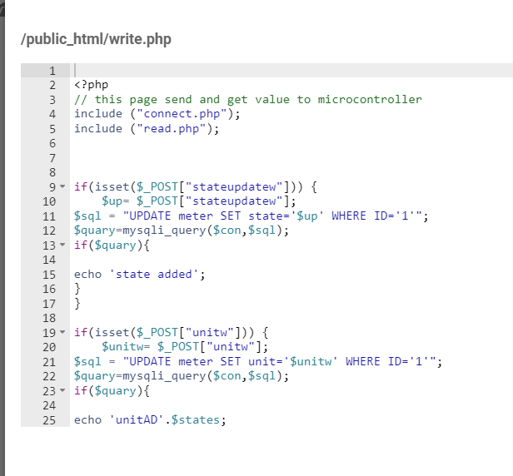

Figure 46 write php file

The write php file writes the home page retrieved data and gsm module retrieved data to database. The isset function means if post request come do this.

### Index php

The index php means home page . the home page makes user interface to user. Home page reads values from read php and write relay state to write page.

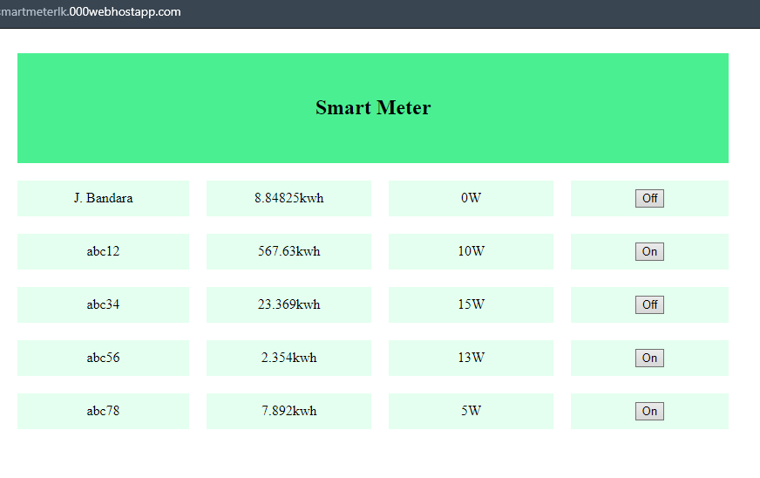

Figure 47 home page

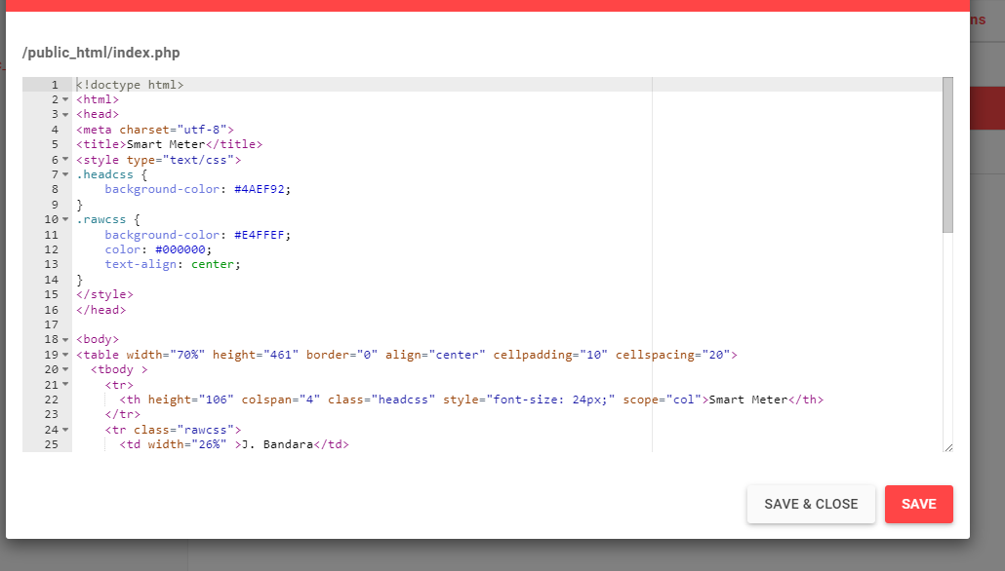

Figure 48 index php sample code

The tag line like <html><head><meta charset="utf-8"><title>Smart Meter</title>

<style type="text/css"> are html tags. The html tags gives user interface.

# Testing and Analyzing

### Gsm test part

For the testing and analyzing part I did gsm testing using sample “AT” command. For this sample “AT” command I made testing gsm unit. It was very helpful for find errors in gsm module programming. The serial communication between gsm and pc done by usb ttl adapter

Usb ttl adapter convert usb interface data to ttl interface data. For this test I chose 3.3v logic level usb ttl adapter. Because sim 800l is 3.3v logic device

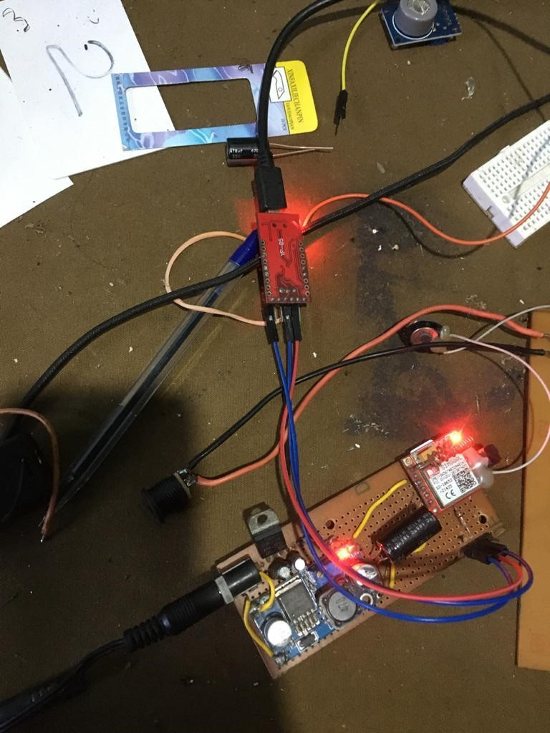

Figure 49 GSM test unit

### Web server test part

For the web server testing part I chose postmen web app. Using postman I updated database using manual post request using postmen web app we can uploaded data separately.

For this project I also had a ability to use GET method instead of POST method. It is easy to handle and easy to check. But post method has more security .Security is very important thing when we release a device to market.

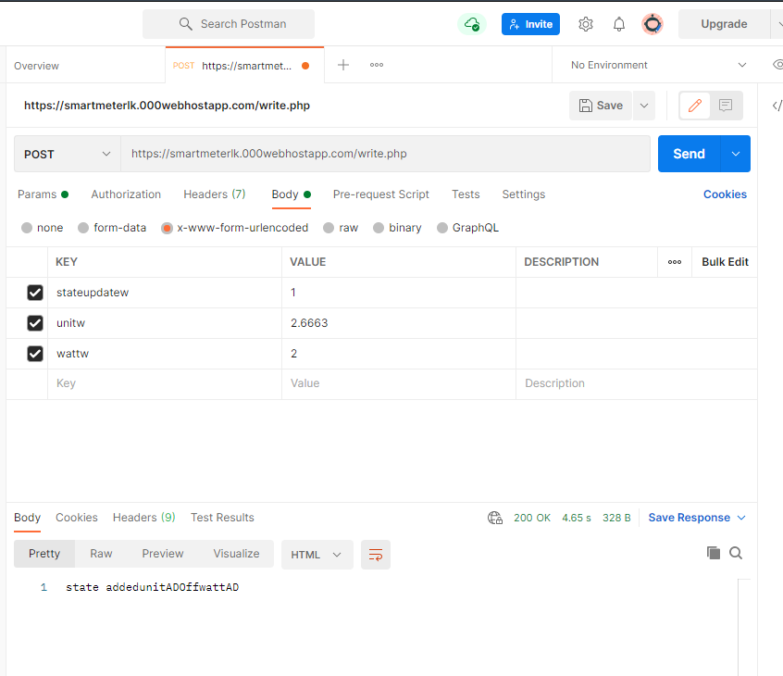

Figure 50postmen web app

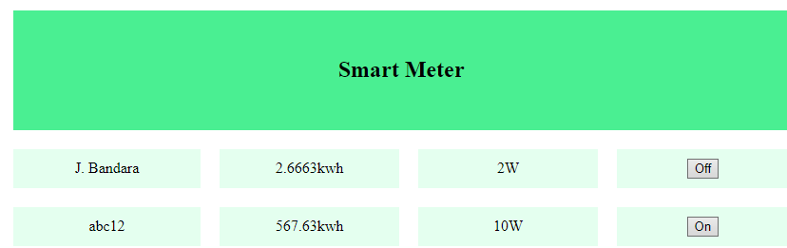

Figure 51 web page after post request

### Finale test

I chose 60W filament bulb for testing. After I connected to circuit. The bulb wire go through the relay. So I switched on the relay from website.

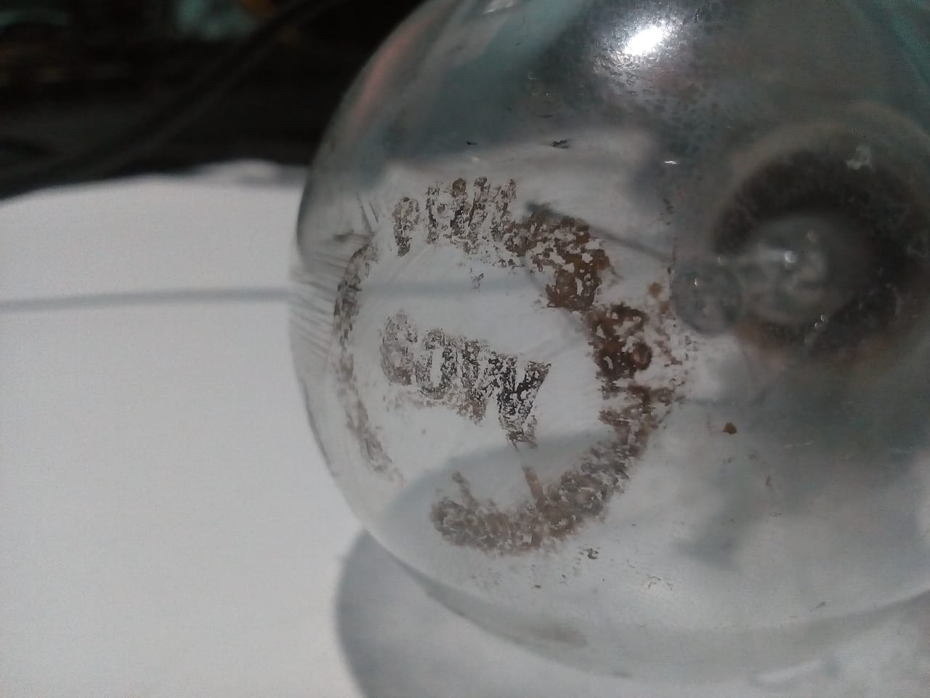

Figure 52 60w filament bulb

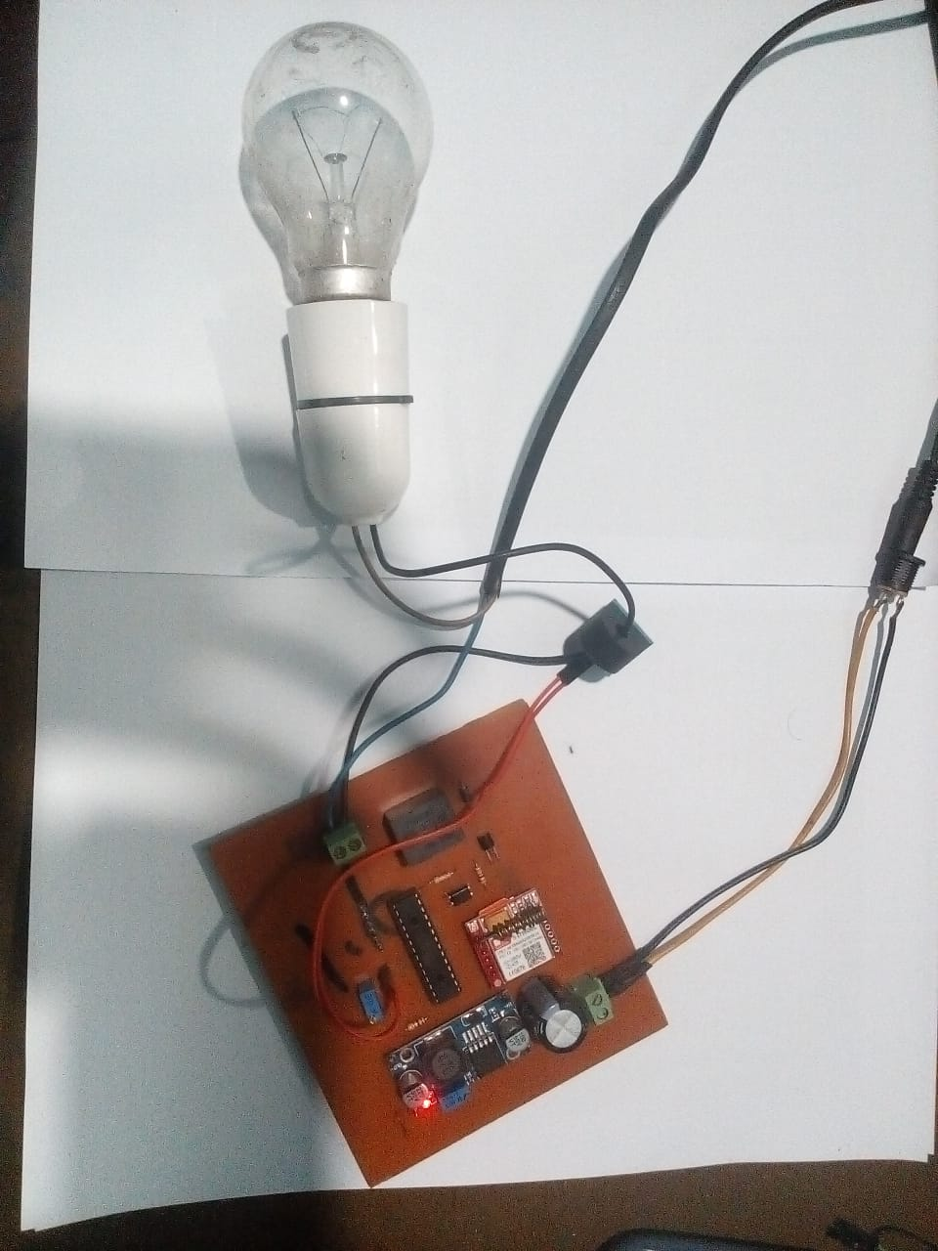

Figure 53 the circuit before test

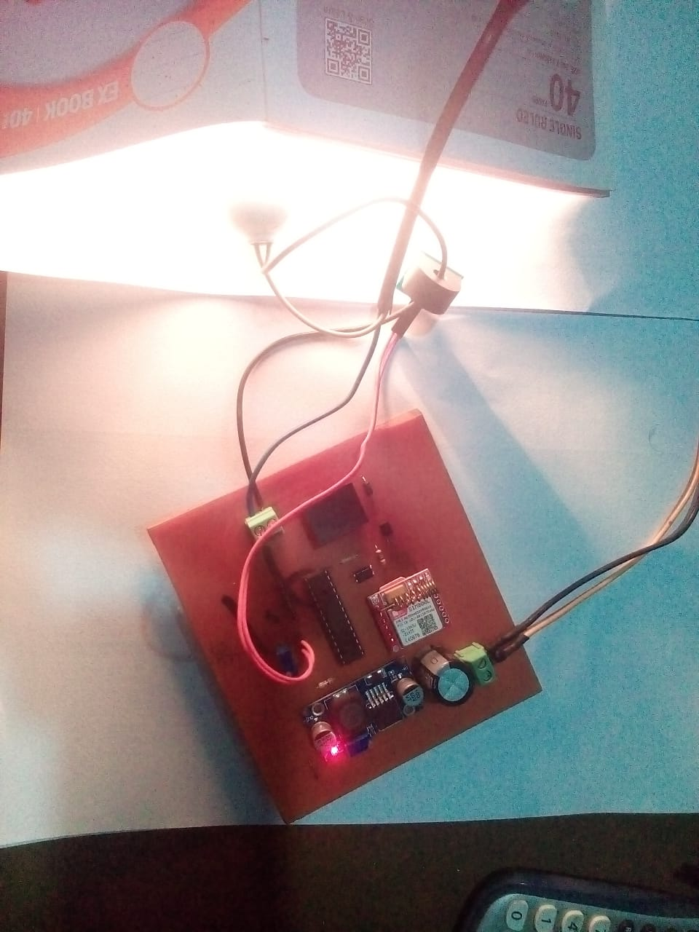

Figure 54 while testing

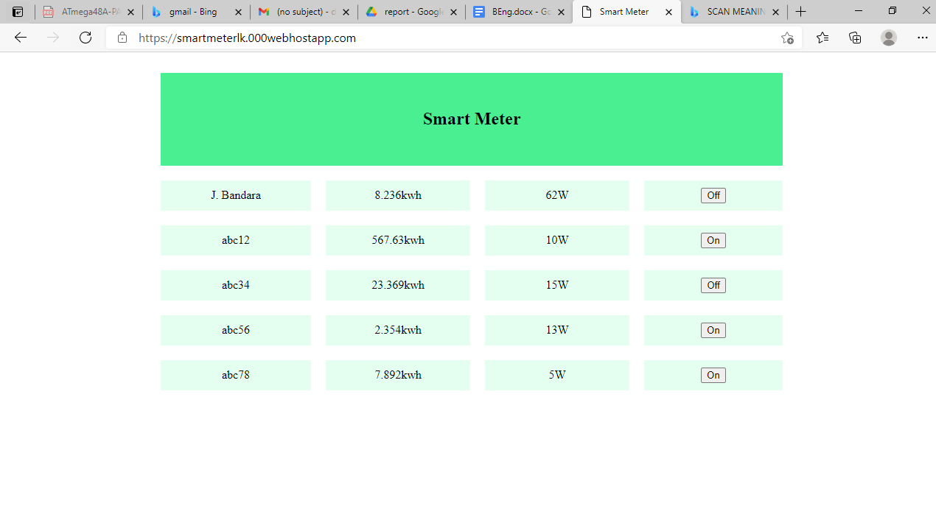

Figure 55 the web page after test

# Conclusion and Further Development

**Actually this project is sample project. I think this device not ready for market. I think this device need few more updates. Actually I have only very basic knowledge about web servers. So I hope to develop this device with experts.**

These are my suggestions .

* I think customer and electricity board need some type of history report like check electricity consumption days separately. I think database part needs to develop for this.
* This device design for domestic users. The maximum value of sensor can read is 5A. but industrial side has large electricity consumption. So we need different type of smart meters for different current levels
* Android and ios app. the it industry develop rapidly. Peoples like get updates using easy method like apps. So I think mobile app is very smart than web site

#### **References**

<https://en.wikipedia.org/wiki/AVR_microcontrollers>

<https://www.newsradio.lk/justin/probe-assault-of-electricity-meter-reader-in-pelmadulla>

<https://www.microchip.com/wwwproducts/en/ATmega328>

<https://lastminuteengineers.com/sim800l-gsm-module-arduino-tutorial/>

#### **Gantt Chart**

Gsm module test 7day

Pcb design 5 day

Pcb manufacturibg 2day

Web site design 2 week

Soldering 1 day

Ic programming 2 week